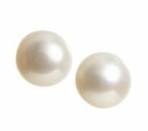
Pediatric Practical
Pearls

Saturday, January 22, 2022
7:45 am to 12:00 pm

“What’s New in Pediatrics?”
https://iu.cloud-cme.com/January2022Pearls

Course Description

Designed for pediatricians, family practice physicians and others providing primary healthcare to children. This course will review current scientific advances as they apply to daily practice. Participants will advance their diagnostic and therapeutic skills through this practical evidence-based review.

Course Objectives

At the conclusion of this course, participants should improve their knowledge in current diagnosis and treatment guidelines and should be able to:

- Identify new STI treatment guidelines in Adolescent Medicine.

- Implement best practices for Covid management and identifying MISC in children; and

- Describe most recent guidelines for management of NAFLD

January 22, 2022
Agenda

7:45 to 8:00 | Welcome to Pearls  Jill V. Helphinstine, MD  Assistant Professor of Clinical Pediatrics  General and Community Pediatrics
8:00 to 9:00 | Talk 1 “Updates in Adolescent Medicine”  Dr. Dennis J. Fortenberry
9:00 | Break – (10 minutes)
9:10 to 10:20 | Talk 2 “Updates in Pediatric GI”  Dr. Jean P. Molleston &  Dr. Kanika Puri
10:20 | Break – (10 minutes)
10:30 to 11:30 | Talk 3 “Update in Infectious Disease”  Dr. Samina S. Bhumbra
11:30 to 12:00 | Bonus Talk - Professional development and promotion.  Dr. Meagan O’Neill &  Dr. Shawn Wilson
12:00 pm | Adjournment

Location

These lectures are held virtually on ZOOM. Zoom link will be sent to all who register.

Accreditation Statement
In support of improving patient care, Indiana University School of Medicine is jointly accredited by the Accreditation Council for Continuing Medical Education (ACCME), the Accreditation Council for Pharmacy Education (ACPE), and the American Nurses Credentialing Center (ANCC), to provide continuing education for the healthcare team.
Physicians
Indiana University School of Medicine designates this live activity for a maximum of 3.75 AMA PRA Category 1 Credits™. Physicians should claim only the credit commensurate with the extent of their participation in the activity.
Click on QR code to Register

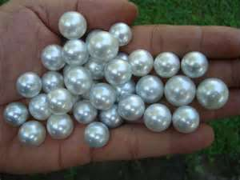
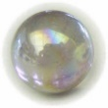

IUSM
Division of
General and Community Pediatrics

Presents
2022
Practical Pearls
Conference

Our January Theme:
“What’s New in Pediatrics?”

Our Mission
- To keep primary care pediatricians updated on a wide variety of topics that impact their day-to-day care of children.

- To focus on important updates for PCPs and "things specialists wish primary care providers knew."

